**Name:-** Mrudula Baraskar

**Class :-** SY.BscCA

**Division:-** A

**Roll no :-** 6185

**Subject:-** Data Communication Practical

**Topic: -** Case study on different noise that occur during data transmission (Analog and Digital) and it’s remedies

Case study on different noise that occur during data transmission (Analog and Digital) and it’s remedies

**Noise:-**

In communication systems, noise is any unwanted signal that interferes with the original message signal during transmission, reception, or processing.  
It distorts the quality of communication and makes it difficult for the receiver to correctly understand the transmitted message.

**Noise Definition :-**

"Any undesired electrical signal or disturbance that reduces the quality, accuracy, or intelligibility of the original information being transmitted in a communication system."

**Introduction:-**

In data communication systems, noise refers to any unwanted signal that distorts or interferes with the transmission of useful information. Both analog and digital transmission are affected by noise, which reduces the quality of communication, causes data errors, and affects system performance. Different types of noise occur depending on the medium, equipment, and environment.

This case study discusses the main types of noise — their definition, cause, effect, and remedies.

**1. Intermodulation Noise**

Intermodulation noise (IM noise), also called *intermodulation distortion (IMD)* is a type of distortion that occurs when two or more signals of different frequencies pass through a non-linear communication device or medium (such as an amplifier, transmitter, or channel).

* Instead of transmitting the original signals cleanly, the nonlinear device mixes them and produces additional signals at new frequencies.
* These new frequencies are usually sum and difference components of the original signals and their harmonics.
* For example, if two signals have frequencies f 1​ and f 2, intermodulation can generate frequencies such as:

f 1 + 2, f1 − f2, 2f1 − f2, 2f2 − f1, 2f1 + f2 ,…

Because these new frequencies are not part of the intended transmission, they interfere with the actual communication and degrade quality.

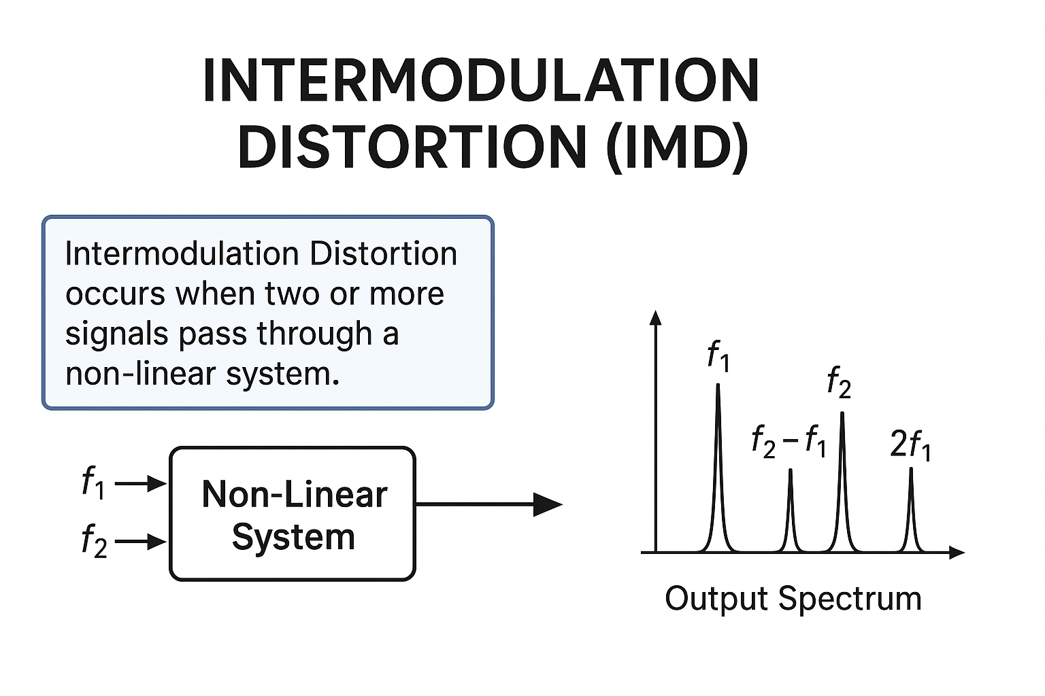

Causes of Intermodulation noise

1. **Adjacent Channel Interference**
   * When signals from neighboring frequency channels are too close, their sidebands may overlap inside nonlinear components, creating intermodulation.
   * Example: In mobile towers, closely spaced carriers (like 900 MHz and 905 MHz) can produce spurious signals.
2. **Environmental Factors**
   * Temperature variations, humidity, or electromagnetic interference from nearby electronic equipment can increase nonlinear behavior of circuits, thus encouraging intermodulation.
   * Example: In satellite communication, sudden temperature changes in space can slightly shift amplifier properties, making them nonlinear.
3. **Passive Intermodulation (PIM)**
   * Even passive components (like connectors, joints, or corroded metal surfaces) can act nonlinearly when strong RF signals pass through, generating intermodulation products.
   * This is especially serious in 4G/5G mobile base stations.
4. **Improper Impedance Matching**
   * When transmission lines, antennas, or circuits are not matched properly, reflections occur, which combine with the main signal and cause mixing.
   * Example: Mismatched antenna systems in wireless networks.
5. **Aging and Component Degradation**
   * Over time, amplifiers, cables, and filters degrade and lose their linearity. Old or corroded hardware increases intermodulation.

Effects of Intermodulation noise

1. **Cross-Modulation Distortion**
   * A strong signal may modulate a weaker one, making the weaker channel carry unwanted variations of the stronger one.
   * Example: In radio broadcasting, a powerful FM station may impose its modulation on a nearby weak station.
2. **Reduction in Data Throughput**
   * In digital communication, intermodulation noise increases bit errors. Automatic repeat requests (ARQ) increase, lowering data speed.
3. **System Instability**
   * Nonlinear mixing may cause oscillations or self-interference within a device, making the system unstable.
4. **Decreased Spectrum Efficiency**
   * Because intermodulation products fall in useful bands, operators must leave extra guard bands (empty frequencies), wasting spectrum resources.
5. **User-Level Impact**
   * Cable TV: Ghost images, hissing sounds, or “phantom” channels.
   * Mobile Communication: Dropped calls, slow internet, poor voice clarity.
   * Satellite Communication: Distorted signals leading to poor navigation accuracy (e.g., GPS errors).

Remedies of Intermodulation Noise

1. **Passive Intermodulation Control**
   * Use high-quality connectors, corrosion-free materials, and proper installation practices.
   * Avoid using ferromagnetic materials in RF paths.
2. **Use of Error Correction Codes (ECC)**
   * Digital systems can include Forward Error Correction (FEC) to recover from errors caused by intermodulation noise.
3. **Antenna Design Improvements**
   * Use antennas with better isolation and low intermodulation characteristics.
   * Maintain physical separation between transmitting and receiving antennas to reduce mixing.
4. **Frequency Planning and Guard Bands**
   * Carefully assign frequencies so that intermodulation products do not fall in active channels.
   * Example: In cellular networks, operators leave “guard bands” between carriers.
5. **Thermal Stabilization**
   * Use cooling systems or temperature-compensated circuits so that amplifier linearity is not lost due to heat.
6. **Digital Signal Processing (DSP) Techniques**
   * Apply adaptive filtering and interference cancellation methods to suppress **intermodulation components before final transmission.**
7. **Power Back-Off**
   * Operate amplifiers below their maximum rated power to maintain linearity and reduce intermodulation risk.

**2.Crosstalk**

Crosstalk is the **unintentional transfer of signals from one communication channel to another**. In digital or analog systems, it occurs when the signal in one wire or circuit induces an unwanted signal in a neighboring wire. This happens because of **electromagnetic coupling**, where energy leaks from one transmission path to another.

* **Simple analogy:** Imagine you are talking on a phone, and someone else’s conversation from a nearby line mixes into your call. That is crosstalk.
* **Occurrence:** Crosstalk is common in:
  + Telephone networks
  + Ethernet (LAN) cables
  + High-speed PCBs in computers and electronic devices

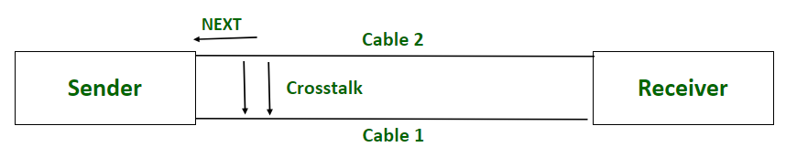

Causes of Crosstalk

Crosstalk occurs mainly due to **poor isolation between channels**. Its technical causes are:

**a) Electromagnetic Induction**

* When a current flows through a wire, it creates a **magnetic field** around it.
* If another wire is close, this magnetic field induces a small voltage in it.
* This is especially significant in **parallel wires** carrying high-frequency signals.

**b) Capacitive Coupling**

* Closely spaced conductors act like a tiny capacitor.
* Voltage changes in one wire induce charges in the neighboring wire.
* This causes unwanted signal transfer, particularly in **high-speed circuits**.

**c) Poor Cable Insulation and Design**

* Low-quality cables without proper shielding or twisted pairs allow signals to leak.
* Older telephone wires and cheap Ethernet cables are more prone to crosstalk.

**d) Parallel Cable Placement**

* Long cables laid side by side increase interference due to magnetic and capacitive coupling.

**e) High-Frequency Signals**

* At high frequencies, electromagnetic coupling becomes stronger.
* Crosstalk is therefore more severe in **high-speed networks**, such as gigabit Ethernet or fast digital circuits.

Effects of Crosstalk

Crosstalk can significantly affect **both analog and digital communication systems**, causing signal distortion, errors, and reduced system performance.

**a) Signal Degradation**

* The original signal gets distorted due to unwanted interference.
* In analog communication, this may make voice signals unclear.
* In digital communication, data signals may fluctuate and become unreliable.

**b) Loss of Privacy**

* In voice communication (telephone), nearby conversations may be overheard.

**c) Increased Bit Error Rate (BER)**

* Digital data can be corrupted when interference alters voltage levels, causing **incorrect interpretation of 0s and 1s**.
* Systems may need retransmission, slowing down communication.

**d) Reduced Data Transmission Speed**

* To compensate for errors, systems often **lower transmission rates**, reducing efficiency.

**e) Signal Integrity Issues**

Crosstalk introduces several **technical problems** in high-speed circuits:

1. **Noise-on-Delay Effect**
   * Noise from crosstalk can **delay the rising or falling edge of a signal**.
   * Delayed signals can cause **timing errors** in synchronous digital circuits.
2. **Logic Faults**
   * Crosstalk may flip the logic level from 0 → 1 or 1 → 0 unintentionally.
   * This causes false outputs in digital circuits or microprocessors.
3. **Voltage Overshoot**
   * Crosstalk may create **spikes above the intended voltage level**, potentially damaging components.
4. **Timing Noise**
   * Random variations in signal arrival times caused by interference.
   * May violate setup and hold times of flip-flops, causing incorrect latching of data.

**f) Customer Dissatisfaction**

* Poor call quality, slow internet, and frequent errors reduce user satisfaction.

Remedies to Reduce Crosstalk

**a) Twisted Pair Cables**

* Twisting wires cancels the induced signals.
* Widely used in modern Ethernet cables (CAT-5e, CAT-6, CAT-7).

**b) Shielded Cables**

* Shielded Twisted Pair (STP) or coaxial cables prevent electromagnetic leakage.
* Fiber optic cables are immune to crosstalk because they use light instead of electricity.

**c) Proper Grounding**

* Provides a path for excess energy to discharge safely.

**d) Adequate Spacing**

* Keep cables or PCB traces apart to reduce coupling.
* On PCBs, traces should be at least **three times their width apart**.

**e) Error Correction Techniques**

* In digital systems: parity checks, CRC, and equalization minimize the impact of residual crosstalk.

**3.Impulse Noise**

**Impulse noise** is a type of **sudden, short-duration, high-amplitude noise** that occurs in communication systems.

* **Characteristics:**
  + Irregular in nature – does not follow a continuous pattern like white noise.
  + Very high amplitude compared to normal signal levels.
  + Lasts for a very short time (microseconds to milliseconds). 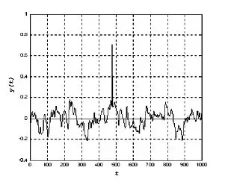
* **Simple analogy:**  
  Imagine you are listening to music, and suddenly a loud “pop” or “click” is heard from your speakers. That unexpected spike is similar to impulse noise in electronics or communication systems.
* **Occurrence:** Impulse noise can affect both **analog and digital systems**, such as:
  + Telephone lines and mobile networks
  + Ethernet or computer networks
  + Audio and video transmission
  + Power lines in industrial systems

Causes of Impulse Noise

Impulse noise is **sudden and irregular**, caused by external disturbances or faulty equipment. Some main causes are:

1. **Lightning Strikes:**
   * A sudden surge in voltage from a lightning strike can produce high-amplitude pulses.
   * Example: A lightning strike near a telephone line can cause a loud pop in the phone line or even damage network equipment.
2. **Switching Equipment:**
   * When electrical switches, relays, or industrial machines turn on/off, sudden voltage changes generate impulses.
   * Example: In factories, turning on a motor may create a short noise spike in connected circuits.
3. **Power Line Disturbances:**
   * Voltage fluctuations or surges in power lines can induce impulses in nearby communication lines.
4. **Faulty Electronic Components:**
   * Components like capacitors, resistors, or transistors may produce spikes when malfunctioning.
   * Example: A failing capacitor in a network router can create short bursts of noise that interfere with data transmission.

Effects of Impulse Noise

Impulse noise is **high amplitude and sudden**, so it can cause severe problems in communication systems:

**a) Digital Systems**

* Causes **burst errors** – multiple consecutive bits may get corrupted.
* Example: In Ethernet or Wi-Fi networks, impulse noise can cause packet loss or corruption.
* May result in **data retransmission**, reducing network efficiency.

**b) Analog Systems**

* Audio: Produces sudden **clicks, pops, or static** in music or voice communication.
* Video: Causes **distorted frames or “glitches”** in video signals.

**c) Signal Integrity Issues**

* Sudden spikes can exceed normal voltage levels.
* May damage sensitive electronic circuits if not properly protected.

Remedies for Impulse Noise

Impulse noise is unpredictable, but there are ways to **minimize or eliminate its effects**:

**a) Error Detection and Correction Codes**

* **Cyclic Redundancy Check (CRC):** Detects errors in digital data packets.
* **Hamming Code:** Can detect and correct single-bit errors caused by impulse noise.
* **Benefit:** Ensures reliable data communication even when bursts of noise occur.

**b) Shielding and Surge Protection**

* **Shielded cables:** Prevent electromagnetic pulses from interfering with signals.
* **Surge protectors:** Absorb high-voltage spikes from lightning or switching events.

**c) Noise Filters**

* Installed in communication or power circuits to **filter out high-amplitude spikes**.
* Example: Line filters on telephone or Ethernet cables reduce sudden noise bursts.

**d) Proper Grounding**

* Ensures that sudden voltage surges are safely diverted to the ground instead of affecting sensitive circuits.

**4. Quantization Noise**

**Quantization Noise** is a type of **error or noise introduced during the conversion of an analog signal to a digital signal**.

* In digital systems, an **Analog-to-Digital Converter (ADC)** converts continuous analog signals into discrete digital values.
* During this conversion, the analog signal is **approximated to the nearest digital level**.
* The difference between the **actual analog value** and the **digitized digital value** is called **quantization error** or **quantization noise**.

**Simple analogy:**  
Imagine you are measuring the height of students using a ruler marked only in whole centimeters.

* A student who is **165.7 cm** will be recorded as **166 cm**.
* The **0.3 cm difference** is like quantization noise in digital systems.

**Occurrence:** Quantization noise is specific to **digital systems**, especially in:

* Audio digitization (MP3, WAV)
* Image digitization (JPEG, PNG)
* Video digitization
* Digital signal processing (DSP) applications

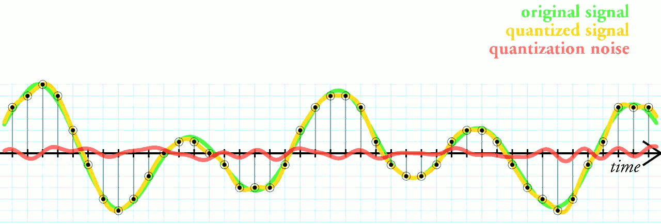

Causes of Quantization Noise

Quantization noise occurs because of the **limited number of quantization levels** in ADCs or digital systems:

1. **Limited Bit Depth**
   * ADCs represent signals with a finite number of bits.
   * For example, an **8-bit ADC** can represent 2⁸ = 256 discrete levels.
   * If the analog signal has values between two levels, the ADC rounds it to the nearest level, producing quantization error.
2. **Signal Approximation**
   * Continuous analog signals have infinite possible values.
   * Digital systems approximate these continuous values with **fixed discrete levels**.
   * The finer the approximation (more levels), the less the quantization error.
3. **High Dynamic Range Signals**
   * If the signal amplitude is high and the ADC has few bits, the difference between actual and approximated signal is large, increasing noise.

Effects of Quantization Noise

Quantization noise affects the **quality of digital signals**:

**a) Reduced Signal-to-Noise Ratio (SNR)**

* Quantization error acts like **random noise**, lowering the **SNR**.
* **Effect:** The signal becomes less clear or distorted in audio, video, or images.

**b) Poor Audio Quality**

* In digital audio, quantization noise can be heard as a **hiss or static** in music or voice recordings.

**c) Poor Image/Video Quality**

* In images, quantization noise can appear as **banding or blocky regions**, especially in gradients.
* Example: A smooth blue sky may appear with visible stripes.

**d) Accumulation in Signal Processing**

* In DSP applications, repeated processing of quantized signals can amplify noise.
* This is critical in **digital filters, audio effects, or scientific measurements**.

Remedies to Reduce Quantization Noise

**a) Increase Bit Depth (More Quantization Levels)**

* Using more bits in ADC increases the number of levels and **reduces approximation error**.
* Examples:
  + 8-bit audio → 256 levels (low quality)
  + 16-bit audio → 65,536 levels (CD quality)
  + 24-bit audio → 16,777,216 levels (studio quality)

**b) Use Advanced Coding Techniques**

* **Delta-sigma modulation**: Converts analog signals with high resolution and reduces quantization noise.
* **Noise shaping**: Pushes quantization noise to frequency ranges where it is less noticeable (common in audio coding).

**c) Dithering**

* Adding a small amount of low-level random noise to the signal before quantization.
* Reduces perception of quantization error in audio or images.

**5.Phase Jitter (Jitter Noise)**

Phase Jitter, also called **Jitter Noise**, is the **tiny, irregular variation in the timing or phase** of a signal.

* In simple words: A signal is supposed to arrive at an exact time (like a train arriving at 5:00 PM). But if the train comes at 5:01 PM or 4:59 PM, it’s "late" or "early."
* This early/late arrival of signals is what we call **jitter**.

In digital systems (computers, networks, telecom), even a small timing error can create **big problems** because data is read and written at very precise clock cycles.

Causes of Phase Jitter

Phase jitter happens due to many real-world issues, such as:

1. **Clock Timing Errors**
   * Digital devices work on clocks (oscillators).
   * If the clock drifts or vibrates slightly, data signals don’t match properly.
2. **Power Supply Fluctuations**
   * If the voltage powering the circuit is not stable, it makes the timing unstable.
3. **Network Congestion / Transmission Delay**
   * In communication networks (like the internet), when too much data travels, packets don’t always arrive evenly spaced, causing jitter.
4. **Electromagnetic Interference (EMI)**
   * Nearby electronic devices or cross-talk between cables can disturb signal timing.

Effects of Phase Jitter

Jitter may seem small, but it has **serious effects** in digital communication:

1. **Data Misalignment**
   * Receiver may read "0" as "1" or miss data bits because timing is off.
2. **Bit Errors**
   * Incorrect data is transmitted, leading to corrupted files, audio glitches, or video distortion.
3. **Loss of Synchronization**
   * Devices working together (sender–receiver) may get “out of sync,” just like dancers missing the beat in music.
4. **Voice/Video Quality Issues** 
   * In VoIP calls, jitter can cause **choppy voice, echoes, or lag**.
   * In streaming video, it causes **freezing or skipping frames**.

Remedies of phase jitter

To reduce or fix jitter, engineers use these methods:

1. **Precise Clock Synchronization**
   * Use high-quality oscillators and keep clocks in sender and receiver tightly synchronized.
2. **Jitter Buffers (in Networks)**
   * A buffer temporarily stores data packets, re-arranges them in correct order, and releases them evenly.
   * This smooths out delays in internet calls or streaming.
3. **Stable Power Supply & Hardware**
   * Use clean, regulated power supplies to avoid voltage fluctuations.
   * Use shielded cables to reduce EMI (Electromagnetic Interference).
4. **Good Network Design**
   * Reduce congestion in networks.
   * Use Quality of Service (QoS) techniques to give priority to real-time data like voice/video.